Steps to Install Anaconda Navigator:

- Go to https://www.anaconda.com/download and then scroll down.
- Double-click the downloaded file and click Continue to start the installation.
- Answer the prompts on the Introduction, Read Me, and License screens.
- Anaconda recommends that you choose Install for me only. If you do not want to install Anaconda Distribution in your home folder, select Install on a specific disk.


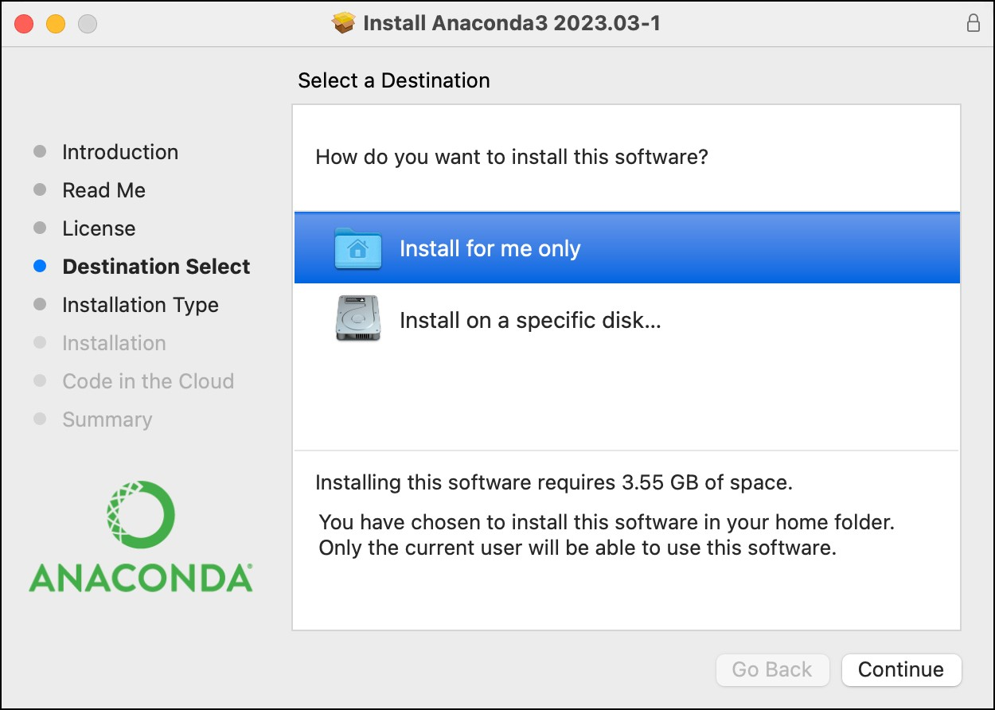
- Click Install.
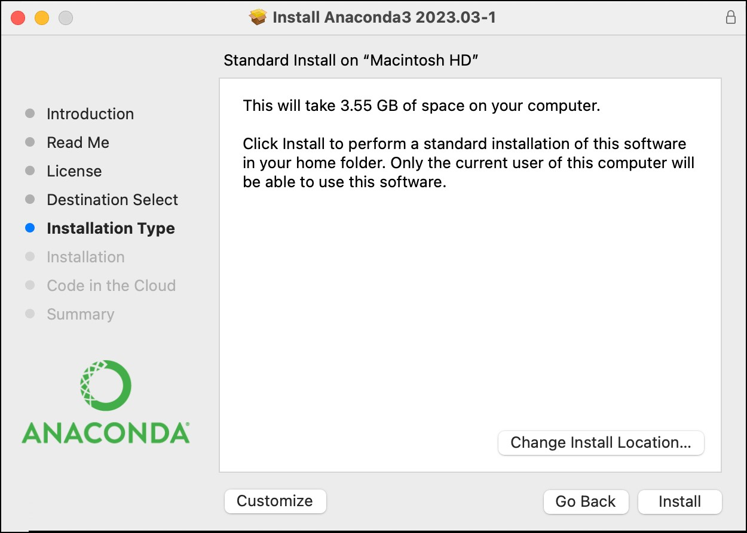
- Once the installation is complete, click Continue to proceed.
A successful installation displays the following screen:
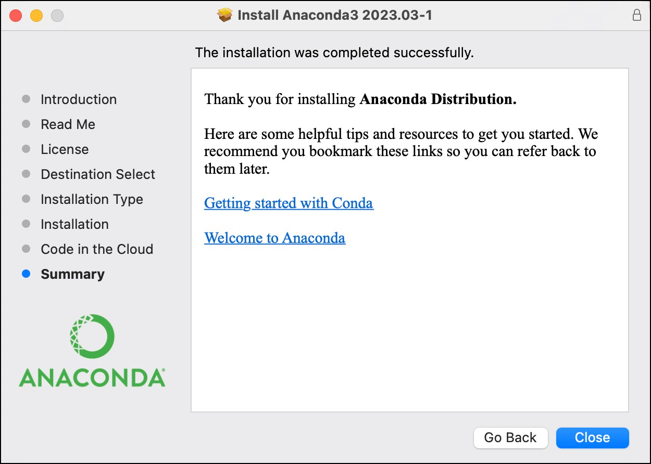
Note: Refer to the given link to visit the official installation website from Anaconda for more information: https://docs.anaconda.com/free/anaconda/install

